EXCERPT
from the minutes No. 1 of the meeting of the Methodological Seminar
of the Department of Electronic Devices and Systems,
Faculty of Electronics, National Technical University of Ukraine “Kyiv Polytechnic Institute” dated October 19, 2022

PRESENT: Yuliia Yamnenko, Valerii Zhuikov, Tetiana Tereshchenko, Viacheslav Chadiuk, Ihor Melnyk, Anatolii Kuzmychiev, Ievgen Verbytskyi, Olena Abakumova, Serhii Sydorenko, Ihor Fedin, Yurii Hramarchuk, Kateryna Klen, Larysa Batrak, Nina Slobodyan, Oleksandr Bondarenko, Leonid Tsybulskyi, Vadym Volkovskyi, Serhii Mykhailov, Pavlo Safronov, Yurii Khokhlov, Ihor Melnyk, Serhii Tuhai, Oleh Bevza, Artur Zahranychnyi, Yuliia Kozhushko, Leonid Pysarenko, Dmytro Mykolaiets, Hanna Saryboga, Volodymyr Perevertailo.

AGENDA ITEM:

1. Clarification of the division of the Department of Electronic Devices and Systems courses by directions. Setting seminar tasks by course blocks.
Presenter: Tetiana Tereshchenko

RESOLVED:

To approve the work plan of the methodological seminars for 2022–2023 academic year.

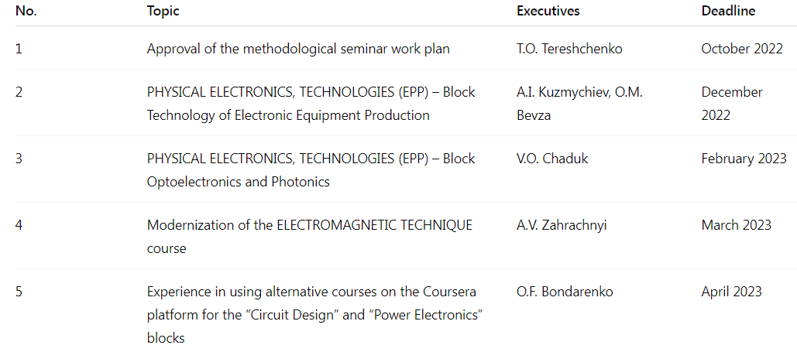

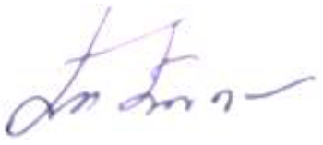
Deputy Head of the Department
for Methodological Work Tetiana Tereshchenko
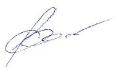

Department Secretary Yurii Hramarchuk

