EXCERPT
from the minutes No. 1 of the meeting of the Methodological Seminar
of the Department of Electronic Devices and Systems,
Faculty of Electronics, National Technical University of Ukraine “Kyiv Polytechnic Institute” dated October 20, 2021

PRESENT: Yuliia Yamnenko, Valerii Zhuikov, Tetiana Tereshchenko, Viacheslav Chadiuk, Ihor Melnyk, Yehor Zheliazkov, Anatolii Kuzmychiev, Vasyl Hromov, Yevhen Verbytskyi, Olena Abakumova, Serhii Sydorenko, Ihor Fedin, Yurii Hramarchuk, Kateryna Klen, Larysa Batrak, Nina Slobodyan, Oleksandr Bondarenko, Oleksandr Terletski, Leonid Tsybulskyi, Vadym Volkovskyi, Liudmyla Laikova, Serhii Mykhailov

AGENDA ITEMS:

1. Clarification of the distribution of the Department’s EPS disciplines by directions. Setting seminar tasks by discipline blocks (presented by T. O. Tereshchenko)
2. Report on changes in the teaching of disciplines of the Microprocessor Technology block (presented by T. O. Tereshchenko)

RESOLVED:

1. Approve the plan of methodological seminars for 2021–2022

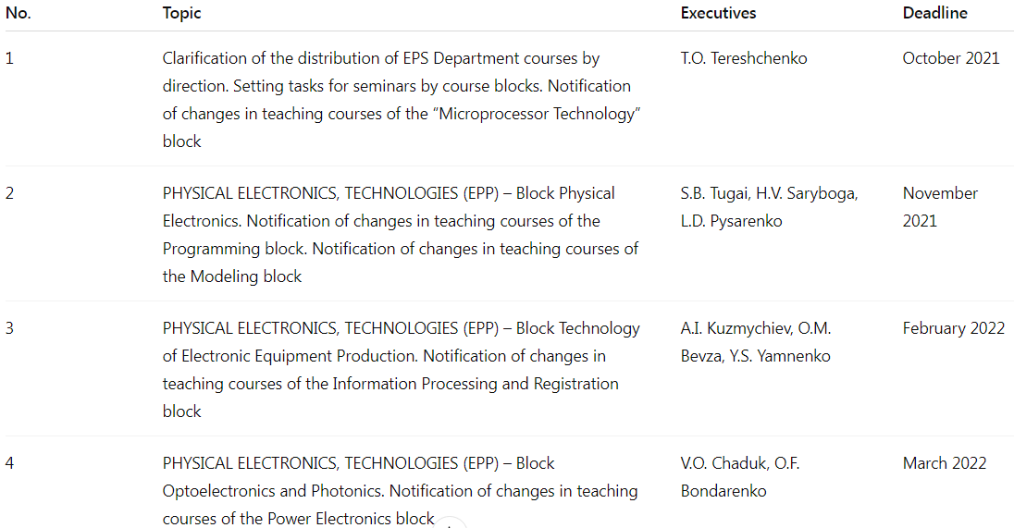
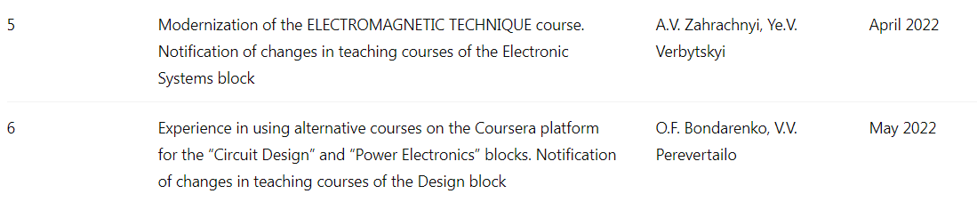

2. Take into account the changes in the teaching of the Microprocessor Technology block

